**Student Design Network:**

**System Design Document**

**l. Introduction              3**

**1.1 Purpose of the system              3**

**1.2 Design goals              3**

**1.3 Definitions, acronyms, and abbreviations              3**

**1.4 References              3**

**1.5 Overview              3-4**

**2. Current software architecture              4**

**3. Proposed software architecture              4**

**3.1 Overview              4**

**3.2 Subsystem decomposition.              4**

**3.3 Hardware/software mapping              5**

**3.4 Persistent data management              5**

**3.5 Access control and security              6**

**3.6 Global software control              6**

**3.7 Boundary conditions              6**

**4. Subsystem Services              6**

**Glossary              7**

**l. Introduction**

**1.1 Purpose of the system**

A. Many of today's social networks are targeted towards keeping in touch with friends, meeting new people, or dating. However, there are no social networks that are specifically targeted towards higher education, or helping employers and students connect easily with each other in a professional environment.

B. Student Design Network should be a place where students, school faculty and employers can come together to create a network of knowledgeable individuals who will have the opportunity to connect with each other.

C. The Student Design Network will be a social networking website, where students can:

1.     Find jobs in their related fields

2.     Post their resume

3.     Post their portfolio

4.     Create a business and educational network

5.     Find help on a forum

6.     Interact with University staff

D. University staff members can also join the social network. They can post information about their classes and help students who need it.  The teachers would be allowed to set up classes where students in those classes can access documents and other helpful information that would be supplementary material to the classroom.

E. Employers can also log into the website and create a profile page for their business.  They can browse through the students' profiles, look at their resumes and portfolios as well as contact the students personally.  Employers will also have the ability to post job listings and target those listings to a certain kind of student.

B. SP ’10

1. Event Calendar: The purpose of the Event Calendar is to give the students the ability to find out about any new events that are Upcoming in their area.

2. Reply to posted Message:

The purpose is to reply to other messages that are posted by users.

3. Create Message:

The purpose is to post a message in the forums

4.Create Master Category:

Create administrative categories to help filter categories created by users and keep them organize.

5.Add-A-Picture to Profile:

The purpose of this system is to provide a globally unique easy-to-use way for the user to upload his/her own unique avatar to their account profile.

FA '10

6. Chat

This system allows users to interact with each other when they are logged in.

**1.2 Design goals**

1) Communication: The system should provide a student with an effective way of connecting with professionals, other students, and teachers in an environment that is more "social" than LinkedIn, but more "network" than Facebook.

2) Intuitive: Because different types of users will be interacting with this site, the Student Design Network should rely on conventions for social networks. Because it's what's most popular, and what people are most used to, the interactivity should take a lot of cues from Facebook.

3) Scalable: Because this network will be built on quarter after quarter, lots of attention should be paid to making this site easy to update and grow. Part of that means commenting EVERYTHING.

**1.3 Definitions, acronyms, and abbreviations**

**User (All) – Student, Staff, Employer, Administrator**

**Database**/**Information** **Storage** (All) - The database that stores the entire website's data is MS SQL 2005 Database

**ASP.NET** – Programming Language

**WebServer** - IIS

**1.4**           **References**

∙        Problem Statement

∙        Requirements Analysis Document

**1.5**           **Overview**

This document is organized as follows: Section 2 presents a brief overview of the current software architecture. Section 3 presents the proposed software architecture, focusing on the subsystem decomposition, hardware and software mapping and the persistent data management. Section 4 presents the subsystems services.

**2. Current software architecture**

There is currently no software in place.

**3. Proposed software architecture**

**3.1 Overview**

This project has the goal of implementing a fully functional online application for students, staff, and employers to network and grow. The system will have a web-based front end and back end.

**3.2 Subsystem decomposition.**

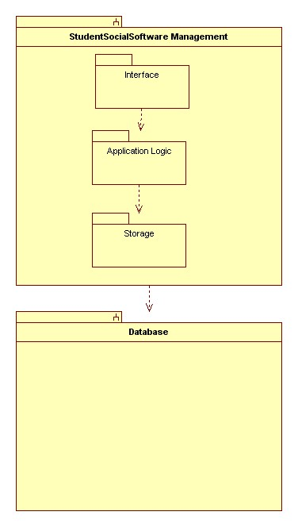

**3.3 Hardware/software mapping**

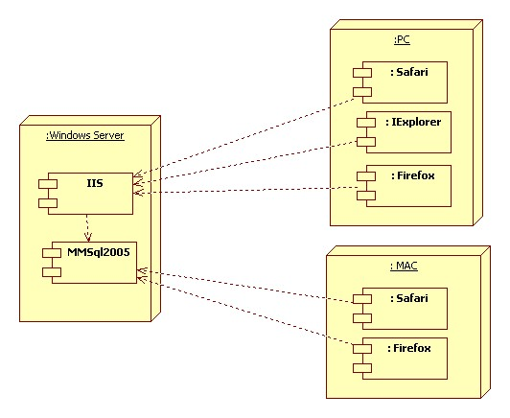

**3.4 Persistent data management**

              MSSQL 2005 Database

**3.5 Access control and security**

Students will only be allowed to view the student section of the website. Staff will be able to view any student’s profile and access the Staff’s section of the website. Employers will have access to student profiles and skill sets and have access to the Employer’s area of the website. Administrators will be able to view any pages (Students, Staff, and Employers) and the administrative area of the website.

|  |  |  |  |
| --- | --- | --- | --- |
| **Objects Actors** | **Resume** | **Account** | **Profile** |
| Students | PrintResume(), CreateResume(), EditResume(),  ViewResume(),  UpdateResume() | LoginToSystem(), LogoutOfSystem().  RateSection(),  PostMessage(),  ReplyMessage()  AddCalendarItem(),  Search(),  PostBookToSell() | CreateProfile(), DeleteProfile(), EditProfile(),  ViewProfile(), |
| Employers | PrintResume(),  ViewResume() | LoginToSystem(), LogoutOfSystem()  PostMessage()  ReplyMessage() | CreateProfile(), DeleteProfile(), EditProfile(), ViewProfile(), |
| Staff | PrintResume(), CreateResume(),  ViewResume(), | LoginToSystem(), LogoutOfSystem(),  PostMessage()  ReplyMessage()  AddCalendarItem(), | CreateProfile(), DeleteProfile(), EditProfile(), ViewProfile(), |
| Administrator | PrintResume(), ViewResume(), | LoginToSystem(), LogoutOfSystem(),  RateSection(),  PostMessage()  ReplyMessage() | CreateProfile(), DeleteProfile(),  ViewProfile(), |

|  |  |  |  |  |
| --- | --- | --- | --- | --- |
| **Objects Actors** |  | **Event Calendar** | **Picture Profile** | **Category** |
| Students | View Calandar(),  CreateMesssage(),  Add Messsaget(),  DeleteMesssage (), |  | Add PictureProfile(),  Delete PictureProfile(),  ViewPictureProfile(), | ViewMasterCategory(), |
| Employers | View EventCalandar(),  Add EventCalandar(),  Delete EventCalandar(), |  | Add PictureProfile(),    Delete PictureProfile(),      ViewPictureProfile(), | ViewMasterCategory(), |
| Staff | View EventCalandar (),  Add EventCalandar (),  Delete EventCalandar (), |  | Add PictureProfile(),    Delete PictureProfile(),      ViewPictureProfile(), | ViewMasterCategory(), |
| Administrator | View Calandar(),  Add EventCalandar(),  Delete EventCalandar(), |  | Add PictureProfile(),    Delete PictureProfile(),  ViewPictureProfile(), | ViewMasterCategory(),  AddMasterCategory(),  DeleteMasterCategory(), |

|  |  |  |  |
| --- | --- | --- | --- |
| **Objects Actors** | **CreateMessage** | **ReplyMessage** | **\*\*** |
| Students | ViewMessage(),  CreateMessage(),  Add Message(),  DeleteMessage(), | ViewMessage (),  CreateMessage(),  Add Message(),  DeleteMesssage(), | ** |
| Employers | ViewMessage (),  CreateMessage(),  Add Message(),  DeleteMessage(), | ViewMessage (),  CreateMessage(),  Add Message(),  DeleteMessage(), | ** |
| Staff | ViewMessage (),  CreateMessage(),  Add Message(),  DeleteMessage(), | ViewMessage (),  CreateMessage(),  Add Message(),  DeleteMessage(), | ** |
| Administrator | ViewMessage (),  CreateMessage(),  Add Message(),  DeleteMessage(), | ViewMessage (),  CreateMessage(),  Add Message(),  DeleteMessage(), | ** |

**3.6 Global software control**

∙        The Three Tier Business Model will control how the system works.  *Student Design NetworkInterface* subsystem will provide the interface for the user interaction.

∙        There will be multiple Business Objects controlling the users and the data.  These will be named with a naming convention adding *BusObject* at the end

∙        Finally there will be the Dataset which will contain all of the data tables and adapters needed to communicate with the business object and the database

**3.7 Boundary conditions**

∙        The system should be running always on the server and should never be down.

∙        User errors will be caught and presented to the users with an error screen.  The errors will be logged for the server administrator to look at and analyze.

**4. Subsystem services**

              Subsystems: StudentSocialNetworkSoftwareManagement (SSNSM), Database

**Glossary**

**Student:** A student is any person that is currently enrolled in the University.

**Staff:** The term staff refers to any teacher that is currently on payroll at the school.

**Employer:** An employer is someone that is looking to employ a student and has been authorized by an administrator to view student profiles.

**Administrator**: An administrator is the term referring to an Aii Space system maintainer who is in charge of creating usernames for the staff and system maintenance.